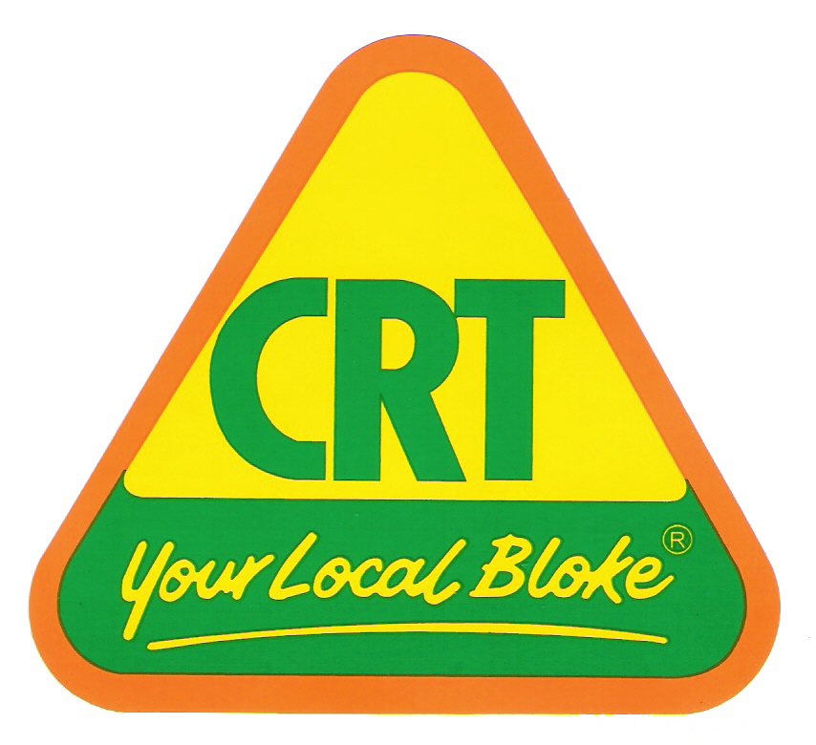
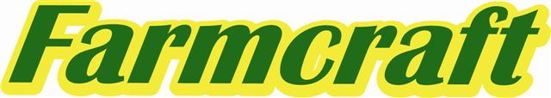
Kalbar, Boonah & Lowood
Ph. 07 54 637 333

Are major sponsors of the
10th ANNUAL
KALBAR WEANER SHOW
& SALE

Saturday, 14th March, 2015
Kalbar Show Ground Yards

Penning curfew 9.00am
Judging starts 10.00am and sale starts at 1.00pm

FOR MORE INFORMATION PLEASE CALL NEIL OR RACHEL GOETSCH
On 07 54 639 040 or 041 7719 671

Kalbar Weaner Show & Sale is proudly sponsored by:

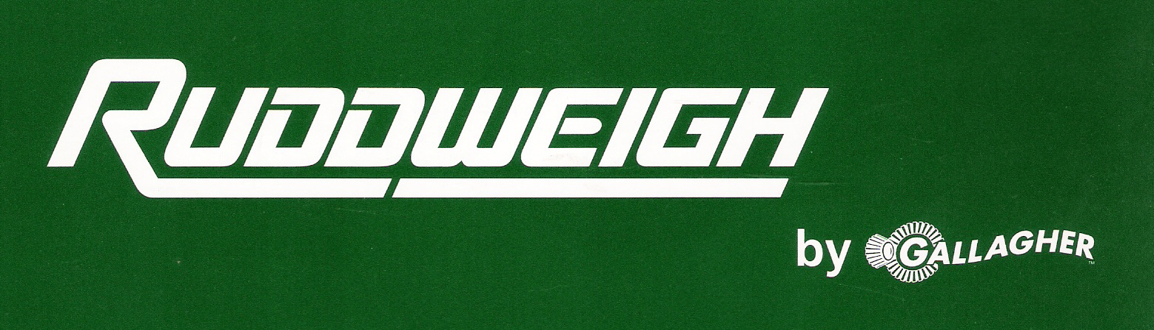

Kalbar, Boonah & Lowood


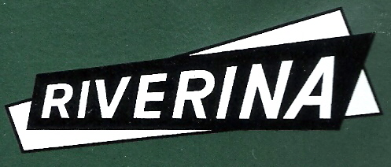

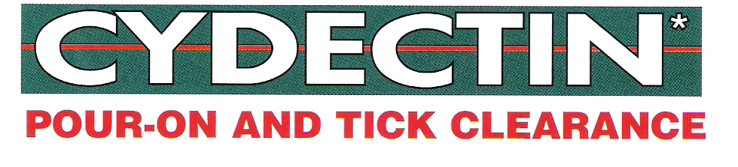








Classes

CLASS 1 Single Weaner Steer
Sponsored by Farmcraft Rural Kalbar, Boonah & Lowood & Z Tags to the value of $100 first place, $50 second place & $25 third place
CLASS 2 Single Weaner Heifer
Sponsored by Farmcraft Rural Kalbar, Boonah & Lowood & AG Solutions to the value of $100 first place, $50 second place & $25 third place
CLASS 3 Pen of 3 to 6 Weaner Steers
Sponsored by Farmcraft Rural Kalbar, Boonah & Lowood & Heritage Seeds to the value of $100 first place, $50 second place & $25 third place.
CLASS 4 Pen of 7 to 12 Weaner Steers
Sponsored by T&T Grains Pty Ltd to the value of $100 first place, $50 second place & $25 third place
CLASS 5 Pen of 3 to 6 Weaner Heifers
Sponsored by Farmcraft Rural Kalbar, Boonah & Lowood & Gallagher/ Ruddweigh to the value of $100 first place, $50 second place & $25 third place
CLASS 6 Pen of 7 to 12 Weaner Heifers
Sponsored by Riverina Stockfeeds to the value of $100 first place, $50 second place & $25 third place
Champion Single Weaner from classes 1 and 2
Sponsored by Footes Kalbar Pharmacy to the value of $250
Champion Pen from classes 3, 4, 5 & 6
Sponsored by Farmcraft Rural Kalbar, Boonah & Lowood & Cydectin Pour-On to the value of $250

Grand Champion Exhibit
Sponsored by Farmcraft Rural Kalbar, Boonah & Lowood & Genesis Pour-on (Ancare) to the value of $500

Encouragement Award
Sponsored by Farmcraft Rural Kalbar, Boonah & Lowood & Virbac (TakTic)
To the value of $100
Weight Guessing Competition
Sponsored by Farmcraft Rural Kalbar, Boonah & Lowood & Pacific Seeds to the value of $50 for Light Weight competition and the value of $50 for Heavy Weight competition.

Many prizes to be won in our Multi Draw
Drawn at end of sale, you must be present to win
10 pack of Portable Yard Panels
Donated by Hans Steel
And many more prizes to be won

