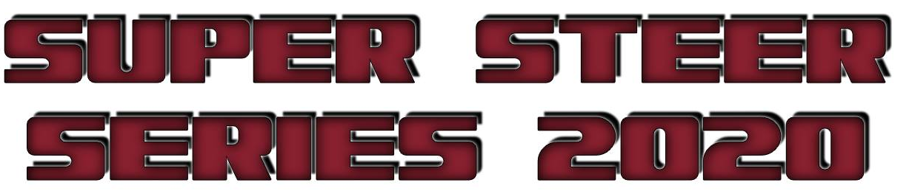


ENTRY FORM

Entries for show location: ………………………………………………….
Class | Animals Name | Breed Steer/Heifer | Entry Fee | Jackpot
 |  |  | $ | $
 |  | Total | $

Name: …………………………………………………………………………………………………………………………………

Address: ……………………………………………………………………………………………………………………………..

Phone No: …………………………………………….. PIC No: ………………………………………………………….

Please email this form to goetschandsons@bigpond.com
The Combined Forces Super Steer Series will be held over 4 shows.
Kalbar Showgrounds on Saturday the 13th of June, 2020.
Toogoolawah Showgrounds on Saturday the 27th of June, 2020.
Allora Showgrounds on Saturday the 4th of July, 2020.
Gympie Showgrounds on Sunday the 2nd of August, 2020.
(This would tie in with steers entered for the Ekka Carcase competition)
ENTRY FEE:
Entry Fees $25 per head per show
Jackpot Entry Fee $50 per head (one of payment per head for all 4 shows)
We are also holding an optional Jackpot competition over the 4 shows, the animal that gets the most points over all 4 shows will take out the Jackpot.
Please email your entries to goetschandsons@bigpond.com or contact our office on
07 54 639 040 if you do not have access to email.
Please direct deposit entries fees to
Goetsch & Sons Trust A/C BSB: 633 000 A/C: 141 252 247
or contact our office for other methods of payment
All entry fees must be paid in full at least 2 days prior to the show date or your entries will NOT be accepted.
CLASSES:
CLASS 1: Steer or Heifer 250 – 350 kg

CLASS 2: Steer or Heifer 351 – 450 kg

CLASS 3: Steer or Heifer 451 – 550 kg

CLASS 4: Steer or Heifer 551 – 700 kg

CHAMPION STEER OR HEIFER
RESERVE CHAMPION STEER OR HEIFER

All enquires to Goetsch & Sons Auctioneers on 07 54 639 040 or Neil 0417 719 671

