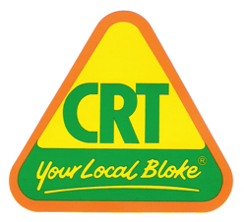
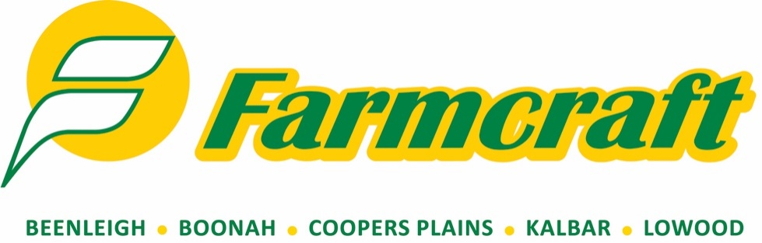

Are major sponsors of the
16th ANNUAL
KALBAR WEANER SHOW
& SALE

Saturday, 20th March 2021
Kalbar Show Ground Yards

Penning curfew 10.00am
Judging starts 12.00noon and sale starts at 2.00pm

Kalbar Weaner Show & Sale is proudly sponsored by:

Classes

CLASS 1 Single Weaner Steer
Sponsored by Farmcraft Kalbar, Boonah, Coopers Plains, Beenleigh & Lowood & Allflex to the value of: $100 first place, $50 second place & $25 third place
CLASS 2 Single Weaner Heifer
Sponsored by Farmcraft Kalbar, Boonah, Coopers Plains, Beenleigh & Lowood & AG Solutions to the value of $100 first place, $50 second place & $25 third place
CLASS 3 Pen of 3 to 6 Weaner Steers
Sponsored by Farmcraft Kalbar, Boonah, Coopers Plains, Beenleigh & Lowood & Barenbrug Seeds to the value of $100 first place, $50 second place & $25 third place.

CLASS 4 Pen of 7 to 12 Weaner Steers
Sponsored by T&T Grains Pty Ltd to the value of $100 first place, $50 second place & $25 third place

CLASS 5 Pen of 3 to 6 Weaner Heifers
Sponsored by Farmcraft Kalbar, Boonah, Coopers Plains, Beenleigh & Lowood & Four Seasons Co to the value of $100 first place, $50 second place & $25 third place
CLASS 6 Pen of 7 to 12 Weaner Heifers
Sponsored by Farmcraft Rural Kalbar, Boonah, Coopers Plains, Beenleigh & Lowood & Pacific Seeds to the value of $100 first place, $50 second place & $25 third place

Champion Single Weaner from classes 1 and 2
Sponsored by Footes Boonah Pharmacy to the value of $250
Champion Pen from classes 3, 4, 5 & 6
Sponsored by Farmcraft Kalbar, Boonah, Coopers Plains, Beenleigh & Lowood & Zoetis to the value of $250

Grand Champion Exhibit
Sponsored by Farmcraft Kalbar, Boonah, Coopers Plains, Beenleigh & Lowood & Eclipse Pour-on (Ancare & Merial) to the value of $500

Encouragement Award
Sponsored by Farmcraft Kalbar, Boonah, Coopers Plains, Beenleigh & Lowood & Virbac
To the value of $100

FOR MORE INFORMATION PLEASE CALL NEIL OR RACHEL GOETSCH
On 07 54 639 040 or 041 7719 671

